**Experiment No. 11**

* 1. **Experiment Name**

Study of the effect of the circuit breaker and observation of the response for 3LG and 1LG fault in transmission line using MATLAB Simulink

* 1. **Objectives**
* To become acquainted with the circuit breaker operation of system
* To understand the operation and simulate observation of the response for 3LG and 1LG fault in transmission line
* To get familiar with the procedure of designing and analyzing a power system in MATLAB
  1. **Theory**

The fault analysis of a power system is required in order to provide information for the selection of switchgear, setting of relays and stability of system operation. Faults usually occur in a power system due to either insulation failure, flashover, physical damage or human error. These faults, may either be three phases in nature involving all three phases in a symmetrical manner, or may be asymmetrical where usually only one or two phases may be involved. The common types of asymmetrical faults occurring in a Power System are single line to ground faults and line to line faults, with and without fault impedance.

* 1. **Required apparatus**
* Simulink
  1. 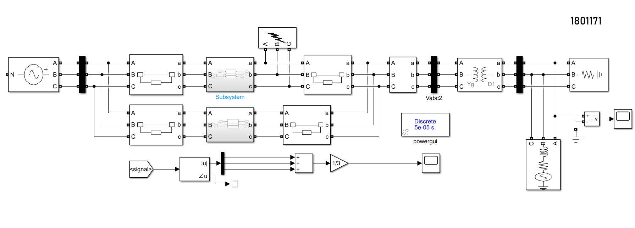**Block diagram**

Fig. 10.1: Circuit diagram for 3LG and 1LG fault in transmission line

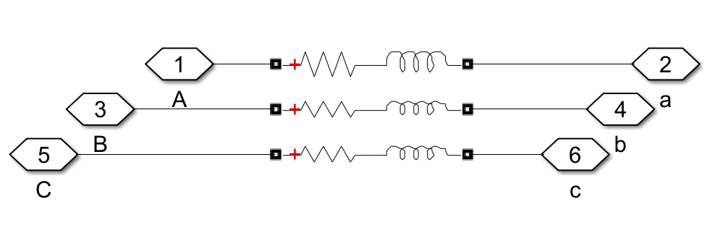

Fig. 10.2: Circuit diagram for logical subsystem

* 1. **Waveform**

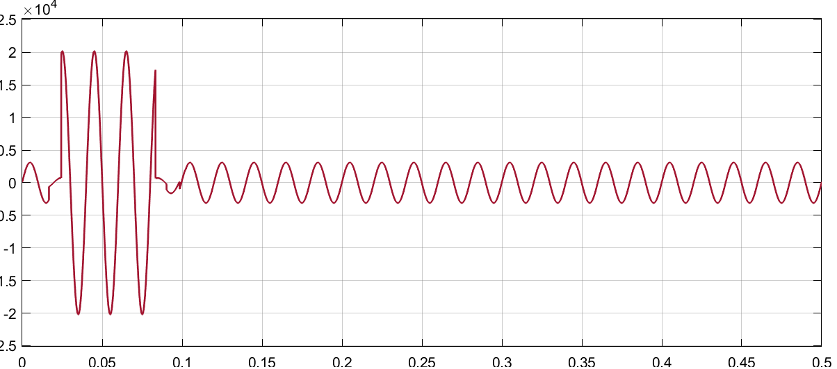

Fig. 10.3: Voltage waveform for 3LG fault in the transmission line

* 1. **Discussion & Conclusion**

The experiment taught us the fault analysis of power system in the Simulink platform. We tweaked the parameters of the generators, loads, and transmission lines after developing it.

Here, we also observed the response for 3LG and 1LG fault in transmission line to evaluate the system. We studied the system and replaced the system's values with new values. The system's objectives were met with success.